#### RUTH FIREW

**Dashboard 1**

View 1: Diabetic/non-diabetic using Shapes

View 2: Patient summary by Blood Pressure category.

View 3: Create a Histogram to show Body Mass Index (BMI) by Age Groups.

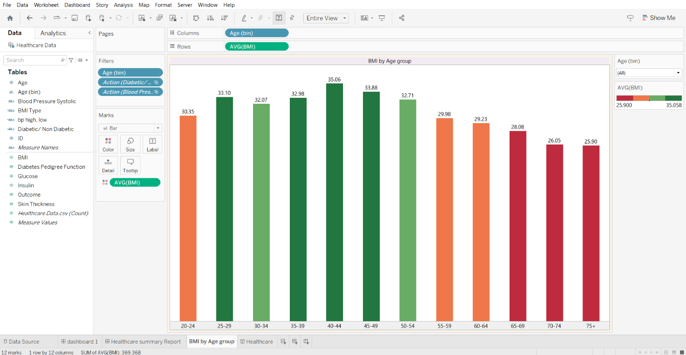

View 4: Single Bar showing percent distribution of patients by BMI type.

View 5: Bar Chart showing Patient break down by Blood Pressure and Diabetes

View 6: Build a HEAT MAP showing several health factors by Age group.

Story Point 1: Should contain Dashboard 1

Story Point 2: Should contain Dashboard 2

Story Point 3: Should contain Heat Map Worksheet

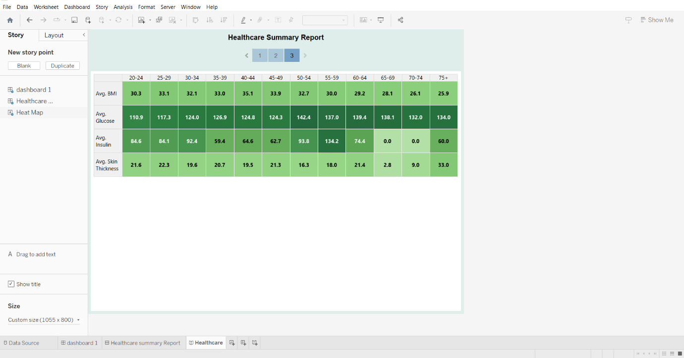

Final view of dashboard 2

